

**YEAR: 9**

**2018**

**SUBJECT: Science**

**TEST: Regulation and Control**

**TIME: 50 minutes**

**QUESTIONS: 10 Multiple Choice (10 marks)**

**6 Short Answer (28 marks)**

**1 Extended (5 marks)**

**TOTAL MARKS: 43 marks**

**DO NOT WRITE ON OR MARK THIS PAPER**

Section 1 – Multi-choice **(10 marks)**

The next two questions refer to the section of the brain illustrated below.

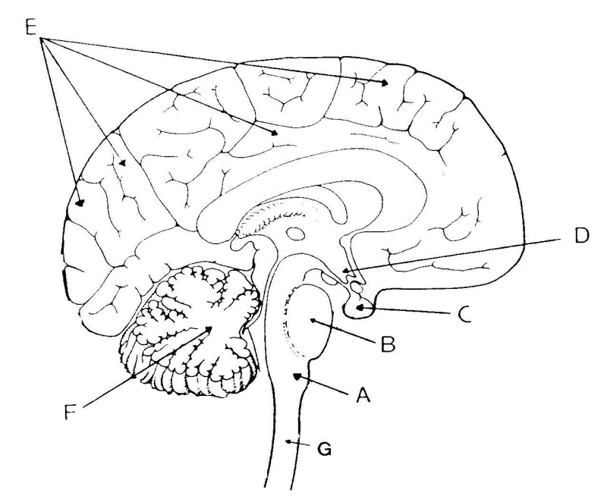

1. Structure E is the

a) hypothalamus.

b) cerebrum.

c) cerebellum.

d) medulla oblongata.

2. The part of the human brain that contains vital centres for regulating heartbeat and   
 breathing is structure:-

a) A  
 b) B  
 c) C  
 d) D

3. In the darkened room, Joel felt a sticky cobweb suddenly cover his face, and he

immediately pulled away. Which type of receptor was used for this action?

a) Vision

b) Taste

c) Touch

d) Sound

4. Which of the following reflexes has to be learnt?

a) Knee-jerk  
 b) Withdrawal of fingers when they touch a hot object  
 c) Catching a ball  
 d) Swallowing

5. The synapse is the

a) path of a reflex arc.  
 b) gap between two neurons.  
 c) the sensory fibre of neurons.  
 d) membranes covering the brain.

6. Identify the activity that would be difficult after sustaining damage to the

1. cerebellum.

a) speech

b) walking

c) breathing

d) intellectual thought.

1. 7. Name two parts of the autonomic nervous system.

a) Central nervous system and parasympathetic nervous system

b) Peripheral nervous system and parasympathetic nervous system

c) Sympathetic nervous system and parasympathetic nervous system

d) Central nervous system and peripheral nervous system.

8. Which of the following is INCORRECT?

a) The central nervous system carries messages to and from all parts of the body.   
 The peripheral nervous system processes information and tells the body how   
 to respond.

b) Motor neurones carry messages from the central nervous system to effectors.   
 Sensory neurones carry messages from cells in the sense organs to the   
 central nervous system.

c) Effectors are muscles or glands that put the messages from the nervous   
 system into effect. Receptors are organs or tissues that have nerve endings   
 that detect changes in the environment.

d) A stimulus is something that you can detect using your sense organs. A   
 response is a reaction to a stimulus.

9. Name the part which occupies more than 80% of the brain and contains over   
 10 billion neurones

a) cerebrum

b) cerebellum

c) brain stem

d) hypothalamus

10. Which one of the following senses is **NOT** found in a particular area?

a) taste.  
 b) touch  
 c) smell  
 d) sight.



**SEMESTER ONE 2018**

**Regulation and Control ANSWER BOOKLET**

**NAME:**

**FORM:** **DATE:**

Multiple Choice Short Answer Extended Answer Total

**/43**

**/15**

**/5**

**/30**

**/28**

**/10**

**/15**

**SECTION ONE:** Multiple choice answers

Cross (X) through the correct answer.

|  |  |  |  |  |
| --- | --- | --- | --- | --- |
| **1** | a | b | c | d |
| **2** | a | b | c | d |
| **3** | a | b | c | d |
| **4** | a | b | c | d |
| **5** | a | b | c | d |
| **6** | a | b | c | d |
| **7** | a | b | c | d |
| **8** | a | b | c | d |
| **9** | a | b | c | d |
| **10** | a | b | c | d |

**Section 2 Short Answer**

Questions 1, 2 and 3 refer to the following diagram

People who accidentally put their hand or finger close to a flame experience a ‘reflex’. This involves the hand automatically moving away from the flame. The diagram below shows the nervous pathway involved.

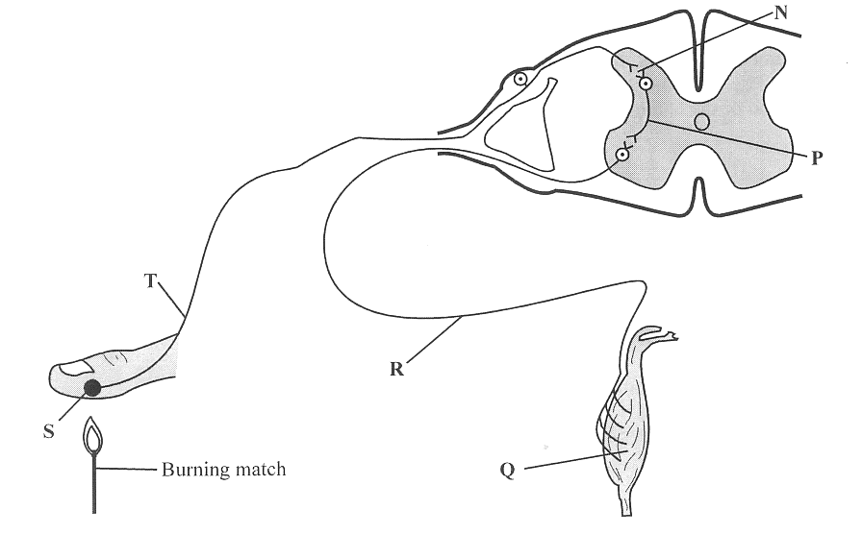

1. Write down the correct letter next to the term. (5 marks)

a) Sensory neuron. ________________

b) Interneuron (also known as the connector or relay neuron) ____________

c) Muscle __________

d) Stimulus _______

d) Motor neuron ________

2. Draw **arrows** on the diagram to show the direction of nerve impulses. (1 mark)

3. Why would it be a disadvantage for the message to go to the brain first? (1 mark)

___________________________________________________________________

___________________________________________________________________

4. Look at the diagram below and then fill in the table underneath it. (8 marks)

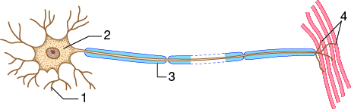

|  |  |  |
| --- | --- | --- |
| Number | Name of structure | Function (What it does) |
| 1 |  |  |
| 2 |  |  |
| 3 |  |  |
| 4 |  |  |

5.Identify the five senses needed to receive information from their surroundings and what they do by filling in the table below. (10 marks)

|  |  |
| --- | --- |
| Sense | Receptor |
|  |  |
|  |  |
|  |  |
|  |  |
|  |  |

6. There are different lobes of the brain that deal with different functions. (3 marks)

Match the following lobes with their function (from the box below) by placing the   
 letter next to them.

Occipital lobe _____

Temporal lobe ____

Frontal lobe ____

|  |
| --- |
| Functions. |
| A. Deals with memory, problem solving and language. |
| B. Deals with sight |
| C. Deals with hearing |

**Extended Answer. (5 marks)**

Underneath is a diagram of a synapse.

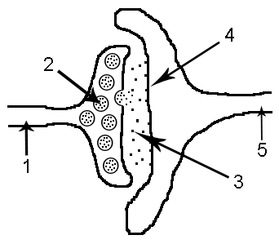

Explain what is meant by a synapse and what is happening in each of the stages that are numbered from 1 to 4.

Synapse _______________________________________________________

______________________________________________________________

1.______________________________________________________________

_______________________________________________________________

_______________________________________________________________

_______________________________________________________________

2. _____________________________________________________________

_______________________________________________________________

_______________________________________________________________

_______________________________________________________________

3. _________________________________________________________________

___________________________________________________________________

___________________________________________________________________

___________________________________________________________________

4. _________________________________________________________________

___________________________________________________________________

___________________________________________________________________

___________________________________________________________________

END OF TEST